DR. AMBEDKAR COLLEGE, DEEKSHA BHOOMI, NAGPUR
INTERNAL COMPLAINTS COMMITTEE

Date: 1st May 2023
Name of the Programme: Lecture on “Prevention of Sexual Harassment in India”
Resource Persons: Adv. Chetan Dhore
Organised by: Internal Complaints Committee (ICC)Cell
Name of Program Co-ordinator: Dr. Sandhya Kalamdhad
Number of Attendees: Around 100
Mode: Online through Google meet

NOTICE

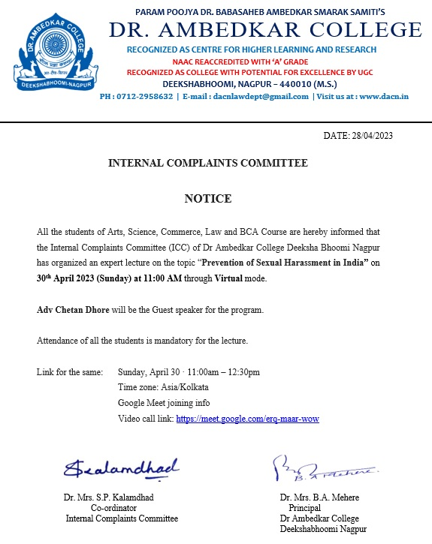

REPORT ON GUEST LECTURE

The Internal Complaints Committee Cell of Dr. Ambedkar College, Deekshabhoomi Nagpur, has organised a Guest Lecture on 1st May 2023 for the students of all fraternity of the college.
Around 100 attendees were present in the program through Online Mode. Adv. Chetan Dhore invited as guest speaker in the program. Dr. B.A. Mehere, Principal of the college gave brief information regarding the topic of the lecture along with the welcome address.

Adv Chetan Dhore commenced the lecture by praising Dr. Babasaheb Ambedkar who have introduced the concept of social justice in constitution of India. He emphasized that the roots of provision of sexual harassment lies in the constitution of India. He focused his arguments also on the Directive Principle of State policy.

Through his commendable talk he appealed the students to first understand that we need to respect the woman. In furtherance to this he vividly explained the students the different forms of Sexual harassment and defined the same with different examples. He elaborately explained how the women are victimised and discriminated since long time. He further briefly narrated the significant and leading cases and the international convention on sexual harassment. He explained the real-life concerned cases, complaint mechanism, conciliation provisions almost all the provisions of 2013 Act on sexual Harassment.

The lecture is followed by the question-and-answer session wherein the different students asked the variety of questions which has been nicely answered by the guest speaker with full satisfaction of the students. He ended his talk by again appealing the students to be sensitive, respectful and be responsible towards the women.

The members of Internal Complaints Committee have graced the event by their presence. The Programme was conducted and concluded with vote of thanks proposed by Dr. Sandhya Kalamdhad, Professor and Co-ordinator of Anti ragging Cell of the college.

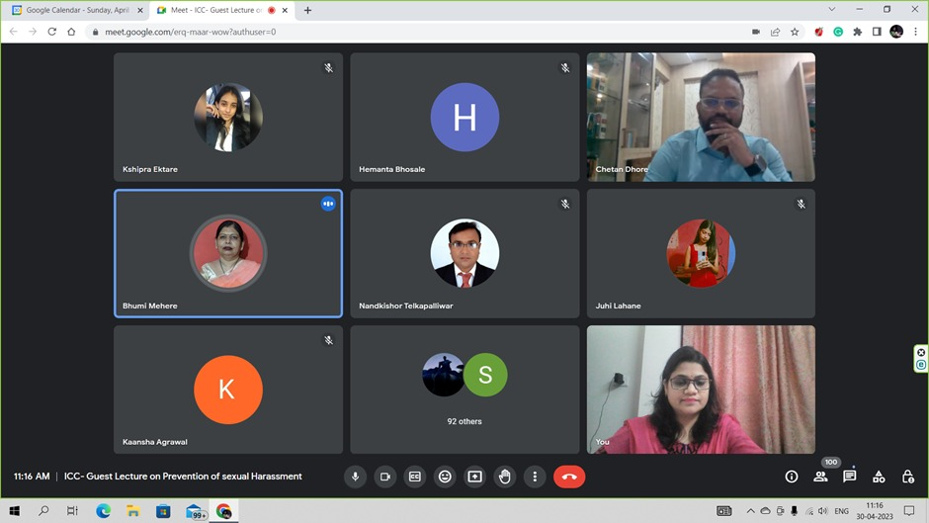
(Dr. B.A. Mehere, Principal of the college giving the introductory remark and welcome address)

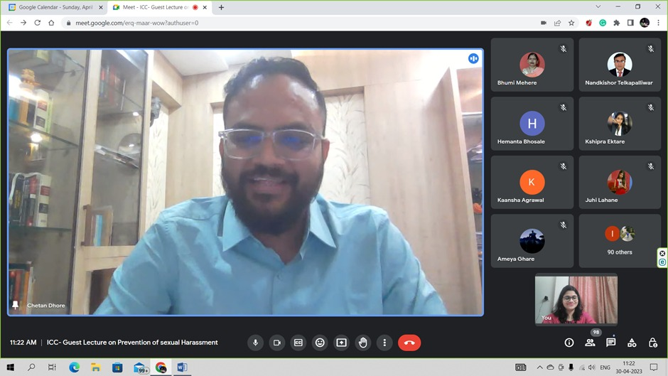
(Adv. Chetan Dhore delivering the lecture)

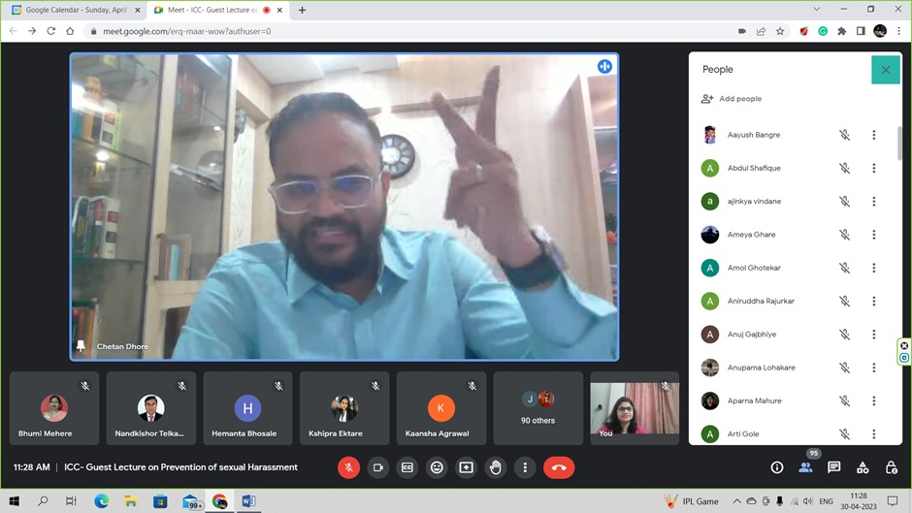

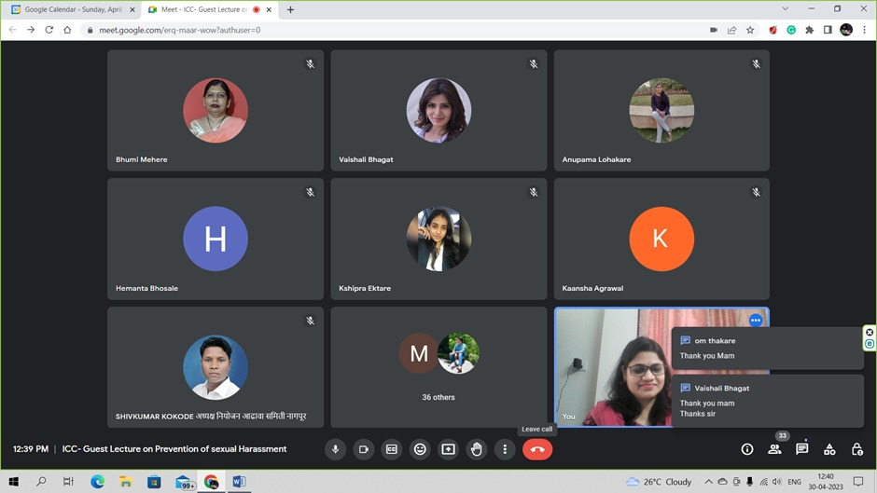
(Audience Present at the Programme through Online mode)

FEEDBACK FORM
